Serviceware Resources
for Android
Release notes 8.4.4

Introduction
This document describes the changes to the Serviceware Resources for Android app, version 8.4.4.
This version prevents registering on invalid session appointments, it also has an important fix for when session appointments are recorded on multiple platforms (web + mobile), and next to that contains changes to be compliant with the new requirements for the Google Play Store.
We hope you will enjoy using this new version of Serviceware Resources for Android and we would like to hear your feedback. You can send this by email (service@serviceware-benelux.com) or use our support phone number: 0031 (0)71-5680310.

Leiden, November 18th, 2025
Serviceware Benelux
Part of Serviceware SE

Table of contents

1 New functionality 4
1.1 Session appointments with invalid orders 4
2 Fixed issues 5
2.1 Registering appointments on multiple platforms blocks synchronization queue 5
2.2 Client and location search date included times 5
2.3 No longer automatically planning only remaining order 5
2.4 Schedule colors made vivid 5
3 Technical notes 6
4 Installation requirements 7

New functionality

Session appointments with invalid orders
When an invalid order is detected for a session appointment, the appointment no longer can be registered on. This is similar to how it would also not be possible for a classic appointment.

The registration tab is also no longer available from the appointment information screen for those appointments.
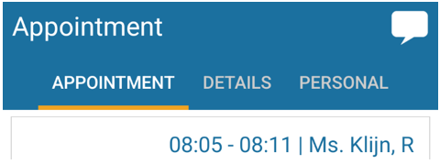

Fixed issues

Registering appointments on multiple platforms blocks synchronization queue
When multiple platforms were used to register session appointments, the synchronization queue could get locked when an appointment was both started on the web and the mobile app in quick succession. The app would then try to add the dynamic form to the registration that was started on the mobile app, but because that sync action was blocked, due to the appointment already being started on the web, it could no longer try to process this form which blocked the entire synchronization process.
The application will now try to check if another registration was found for the appointment in case of this scenario and will attempt to connect the form to the registration it received from the web before placing it in the synchronization queue.
💡Keep in mind that starting a registration for the same appointment on multiple platforms in quick succession is not a correct way of working and should be avoided.

Client and location search date included times
The initial search date that was used in the client and location search was not correctly set to just the current date but also included the current time, this could cause clients and locations to not be found correctly on the last day of their validity if the user did not change the date to search on.

No longer automatically planning only remaining order
When searching for a client to plan in a session, the app would automatically select the only remaining order and plan it directly, even if it did not match the search input given. It now correctly only automatically selects the only remaining order if it matches the search input when searching for the client. In all other cases the user must explicitly pick the correct order, if multiple orders were found and one was found to match the search input, it is still pre-selected and marked to aid the user to pick the one matching the search input.

Schedule colors made vivid
The colors for certain types of schedules were a bit too faint. We’ve adjusted the colors in the apps to be more vivid, so they are clearer to the users.
Old colors on the left vs new colors on the right
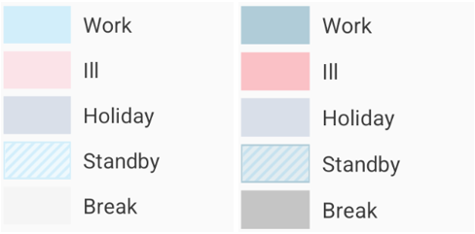

Technical notes
To stay compliant with the Google Play Store requirements this version of the app has the following changes:
- Updated Android SDK level from Api 34 to Api 35
This has brought some changes which are mostly related to the user interface. When running on a device with Android 15 or higher you will no longer see the colored system bar, but Google now enforces apps to be ‘edge-to-edge’, so the top bar is extended to be fully visible behind the system bar.
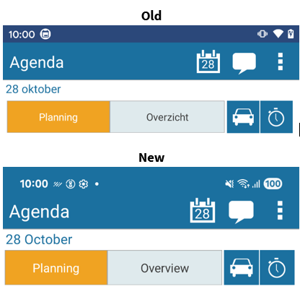

Installation requirements
The following items are required for the installation of Serviceware Resources for Android 8.4.4:
- Serviceware Resources for Android 8.4.4 is compatible with all Serviceware Resources (web) versions in the 7 and 8 series.
- Windows Server 2008 SP2 or higher. In the case of the server having Windows Server 2008 installed, it needs to have at least Service Pack 2 or higher. Windows Server 2008 SP1 is not supported because of an issue with Microsoft .Net.
- The webserver needs to have Microsoft .Net 8 installed to run the Serviceware Resources 8.5 or higher Mobile Api.
- The Android devices require at least Android version 6.0, but we recommend a minimum of Android 11.
- Total list of supported Android versions:

  - Android 6 (Api 23)
  - Android 7 (Api 24) / 7.1 (Api 25)
  - Android 8 (Api 26) / 8.1 (Api 27)
  - Android 9 (Api 28)
  - Android 10 (Api 29)
  - Android 11 (Api 30)
  - Android 12 (Api 31) / 12.1 (Api 32)
  - Android 13 (Api 33)
  - Android 14 (Api 34)
  - Android 15 (Api 35)
  - Android 16 (Api 36)

For a complete list of hardware and software requirements, see: “Serviceware Resources - Hard- and Software specifications _EN_v83”.

